**Southern Highlands Conference on Heterocyclic Chemistry**

**Sebel Harbourside Kiama 28th – 30th August 2022**

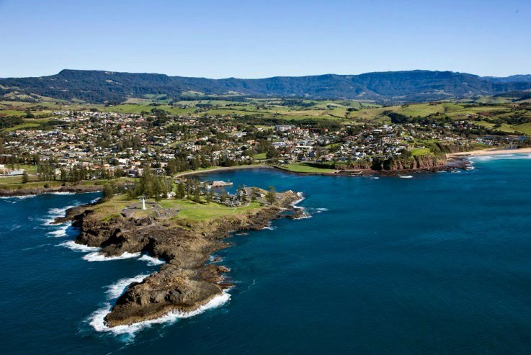 ABN 81 747 687 337



**Registration Form**

Title: Prof  A/Prof  Dr  (blank)

|  |  |
| --- | --- |
| Full name |  |
| Gender (for room allocation) |  |
| Phone number |  |
| Business address |  |
| Email address |  |

***Registration fees including accommodation and meals (payable by 28 July 2022)***

**AUD $595 pp twin share**

**AUD $780 pp single room**

|  |  |
| --- | --- |
| Total payment (in addition to any bank fees) |  |

Payment format: Direct deposit

Commonwealth Bank, UNSW Branch

Account name: Southern Highlands Conference

BSB 062 303

Account 1057 4142

|  |  |
| --- | --- |
| Dietary requirements |  |
| Preferred room partner * |  |

* Note: If you do not indicate a preferred room partner, we will allocate room buddies.

***Conference presentations***

I wish to present:  (Lecture for students only)

|  |  |
| --- | --- |
| Title and author  (Indicate presenter) |  |

***Travel arrangements***

I will travel to Kiama by:  car  train  flight to Shellharbour  other

Note: Link airways flies direct from Sydney, Brisbane, Melbourne (Essendon), Canberra, Hobart and Newcastle) to Wollongong (Shellharbour) which is 15 minutes’ drive to the conference venue. Collection from the airport can be arranged. For more information visit <https://www.linkairways.com/>

Please return registration form by July 28th 2022 to:

Paul Keller

[keller@uow.edu.au](mailto:keller@uow.edu.au)

(02) 4221 4692

0407 904 373

Proceedings will begin at 3.30 pm on Sunday with afternoon tea and the first two plenary lectures, and conclude at about 3.30 pm on Tuesday afternoon.

**Postgraduate Student awards**

To encourage student participation and to reward excellence in chemistry, two awards, equivalent to half of the conference registration costs, have been created and will be made to postgraduate students from any Australian university. Awardees will be invited to present a lecture on their research work at the conference. Nominations for the awards must be made in writing with a CV, letter of recommendation and A4 abstract to Professor Paul Keller at the registration address by July 16th 2022.

Postgraduate Poster prizes will also be awarded.

**Map to Venue**

(travelling by car from the North)

